Assignment No. 07

Roll No. SC55 - Shreyas Chavhan

===================================================

# Exception Handling

## Problem Statement -

Create user defined exception to check the following conditions and throw the

exception if the criterion does not meet.

a. User has age between 18 and 55.

b. User stays has income between Rs. 50,000 - Rs. 1,00,000 per month

c. User stays in Pune/Mumbai/Banglore/Chennai

d. User has 4-wheeler

Accept age, Income, City, Vehicle from the user and check for the conditions

mentioned above. If any of the condition not met then throw the expception;

## Theory -

C++ Exceptions

When executing C++ code, different errors can occur: coding errors made by the programmer, errors due to wrong input, or other unforeseeable things.

When an error occurs, C++ will normally stop and generate an error message. The technical term for this is: C++ will throw an exception (throw an error).

C++ try and catch

Exception handling in C++ consist of three keywords: try, throw and catch:

The try statement allows you to define a block of code to be tested for errors while it is being executed.

The throw keyword throws an exception when a problem is detected, which lets us create a custom error.

The catch statement allows you to define a block of code to be executed, if an error occurs in the try block.

## Code -

|  |
| --- |
| /*******************************************************************************  Assignment no. 7 -  Create user defined exception to check the following conditions and throw the  exception if the criterion does not meet.  a. User has age between 18 and 55.  b. User stays has income between Rs. 50,000 - Rs. 1,00,000 per month  c. User stays in Pune/Mumbai/Banglore/Chennai  d. User has 4-wheeler  Accept age, Income, City, Vehicle from the user and check for the conditions  mentioned above. If any of the condition not met then throw the expception;  *******************************************************************************/  #include <iostream>  using namespace std;  int main(){  int age, income, vehicle_wheels;  string city;  cout << "<age> <income> <city> <No. of wheels>" << endl;  cin >> age >> income >> city >> vehicle_wheels;  try{  if(age > 18 && age < 55 && income > 50000 && income < 100000 && vehicle_wheels == 4 && (city == "Pune" || city == "Mumbai" || city == "Banglore" || city == "Chennai")){  cout << "All Condtions met" << endl;  }  else{  throw age;  }  }  catch(int age){  cout << "Condtions not met." << endl;  }  return 0;  } |

Roll No. SC55 - Shreyas Chavhan

===================================================

## Output -

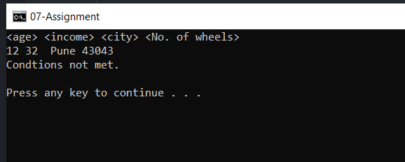

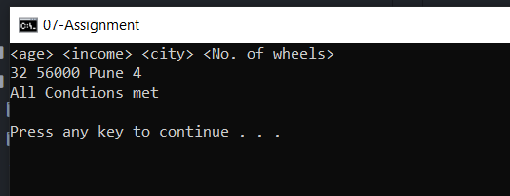

===================================================

Roll No. SC55 - Shreyas Chavhan